**Getting API ID and API HASH from Telegram Developer Portal**

**## Step 1:**

- Open API Development Tools (<https://my.telegram.org/auth?to=apps>)

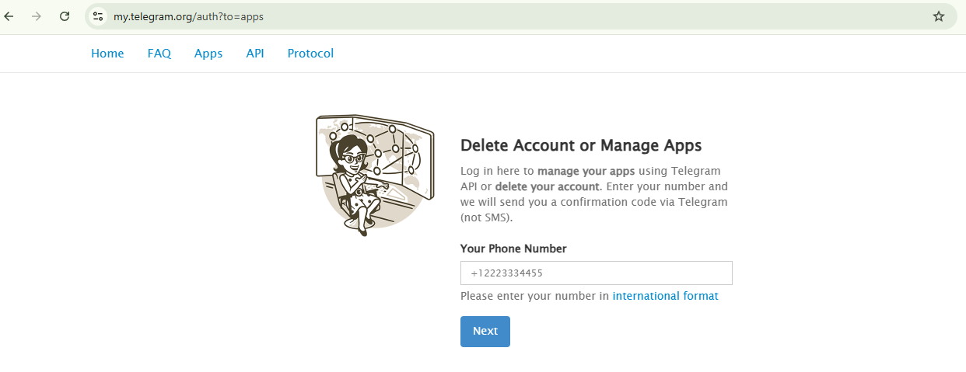

**## Step 2:**

- Enter your Phone number along with the Country code.

- After entering the Phone number click on Next and enter the confirmation code which you received on you telegram account and click on Sign In.

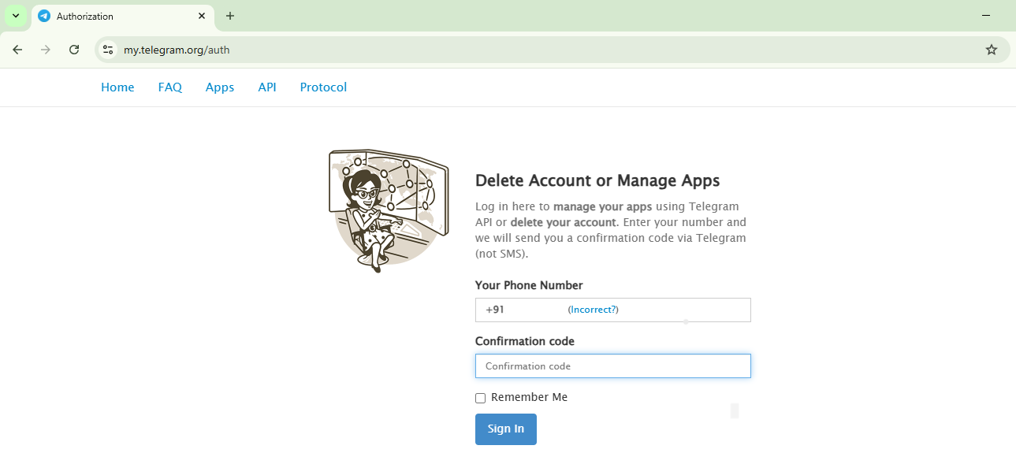

**## Step 3:**

* Click on create application.

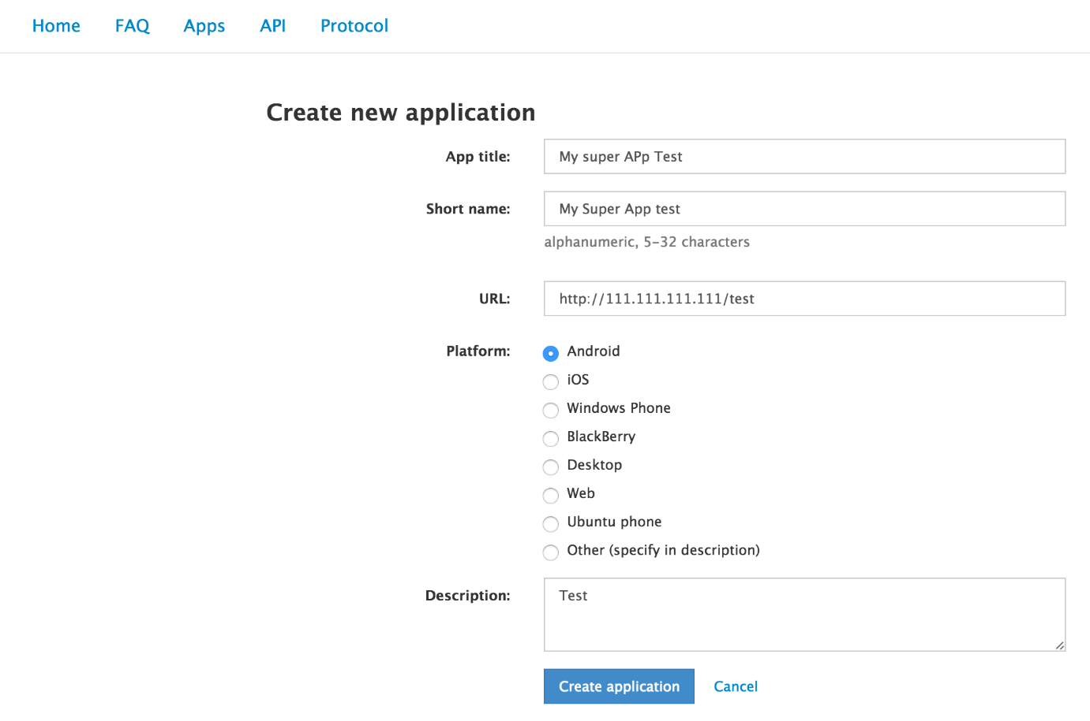

* After logging in, you'll see a page with options. Click on the **"Create New Application"** button to start setting up your Telegram API app

**## Step 4**

**Enter the Required Details**

You’ll be asked to fill out a form with the following details:

* **App title** → The name of your application. Example: MyTelegramBot
* **Short name** → A shorter version of your app's name (can be the same as the title but without spaces). Example: mytelegrambot
* **URL** → Any website URL (not strictly required to be real). Example: https://example.com
* **Description** → A brief description of your app. Example: This app is for automating Telegram tasks.
* After entering the details, click the **"Create"** button. Once done, Telegram will generate your **API ID** and **API Hash**—these are the credentials you’ll use in your Telegram API or Telethon scripts.